SM4_results **– Description of results - Figures**

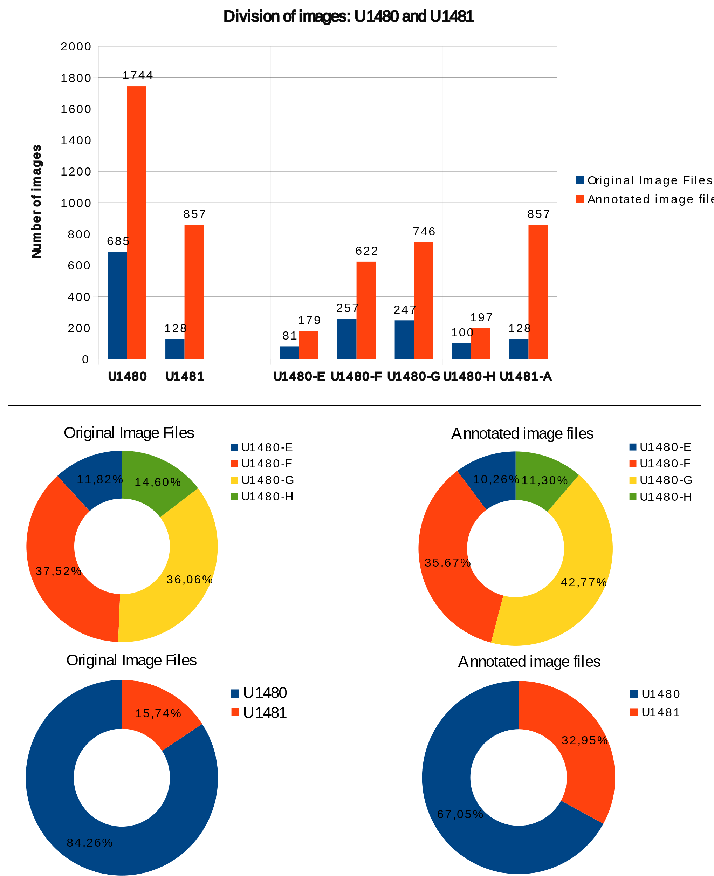

Figure 1 Summary of the composition of the original images and images annotated by site U1480 and site U1481 and holes E, F, G and H to U1480 and A to U1481. Original images are files acquired directly from the expedition, in high-resolution format. Annotation images are files created from the original images through annotation as described in chapter 2.3.

Figure 2 Division between original records and interpolated records for dataset1, U1480 and U1481. The geophysical properties are: Gamma Ray Attenuation bulk density (GRA), Moisture and Density (MAD), Magnetic Susceptibility (MS), Natural Gamma Radiation (NGR), P-Wave Velocity Logger System (PWL), Red Green Blue channels (RGB) and Reflectance Spectrophotometry and Colorimetry (RSC).

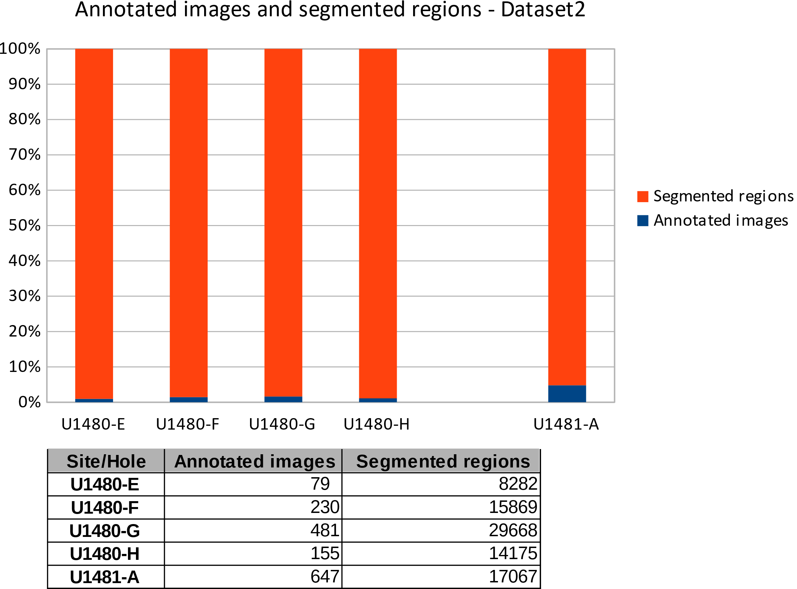

Figure 3 Summary of the formation of dataset2 between annotated images and segmented regions. Site/Hole covers sites U1480 and U1481 in the defined range.

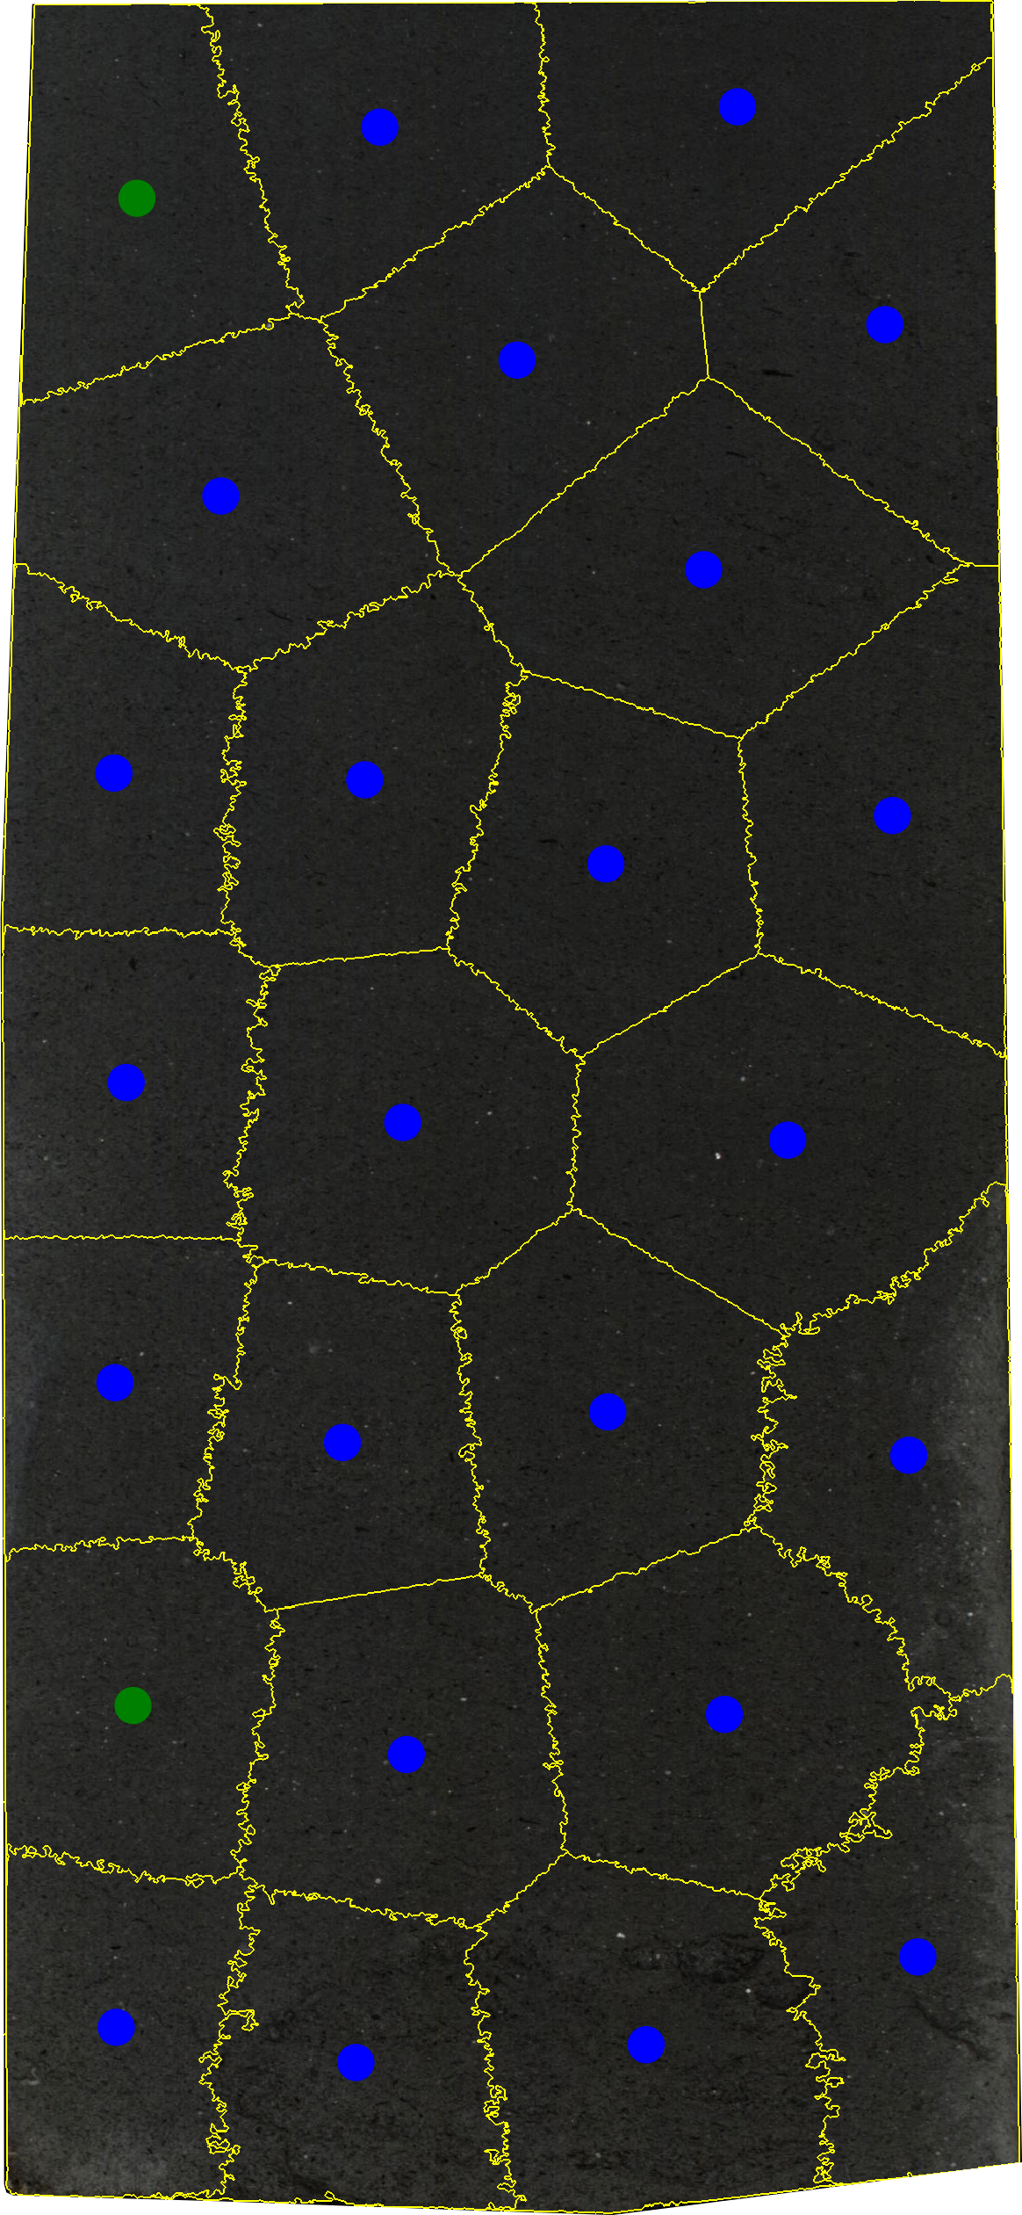

Figure 4 Classification of the segmented regions for the image: 362-u1480g-52r-3-a; region-1; Fine-sand_sandstone.png, lithology: Fine sand/sandstone, total segmented regions: 25, combination training and testing: 90%Train – 10% Test, Apx: 71,48 cm². Caption in blue: Training, Caption in green: Test with correct classification and Caption in red: Test with incorrect classification.